EXPERIMENT 10

IMAGE ROTATION USING OPENCV

AIM
To rotate an image by 90 degrees clockwise using Python and OpenCV.

SOFTWARE REQUIREMENTS
- Python
- OpenCV library
- Notepad
- Command Prompt

PROCEDURE
- Open Notepad and type the Python program for image rotation.
- Import the OpenCV library using import cv2.
- Read the input image using cv2.imread().
- Rotate the image by 90 degrees clockwise using cv2.rotate() and cv2.ROTATE_90_CLOCKWISE.
- Display the original and rotated images using cv2.imshow().
- Save the rotated image using cv2.imwrite().
- Close the image windows using cv2.destroyAllWindows().

PROGRAM
import cv2

img = cv2.imread("scaling_image.png")

if img is None:
print("Image not found! Check the image name.")
else:
rotated = cv2.rotate(img, cv2.ROTATE_90_CLOCKWISE)

cv2.imshow("Original Image", img)
cv2.imshow("Rotated Image - 90 Degrees Clockwise", rotated)

cv2.imwrite("rotated_image.png", rotated)

cv2.waitKey(0)
cv2.destroyAllWindows()

print("Rotated image saved successfully!")

OUTPUT
The original image and the image rotated by 90 degrees clockwise are displayed. The rotated image is saved as rotated_image.png.
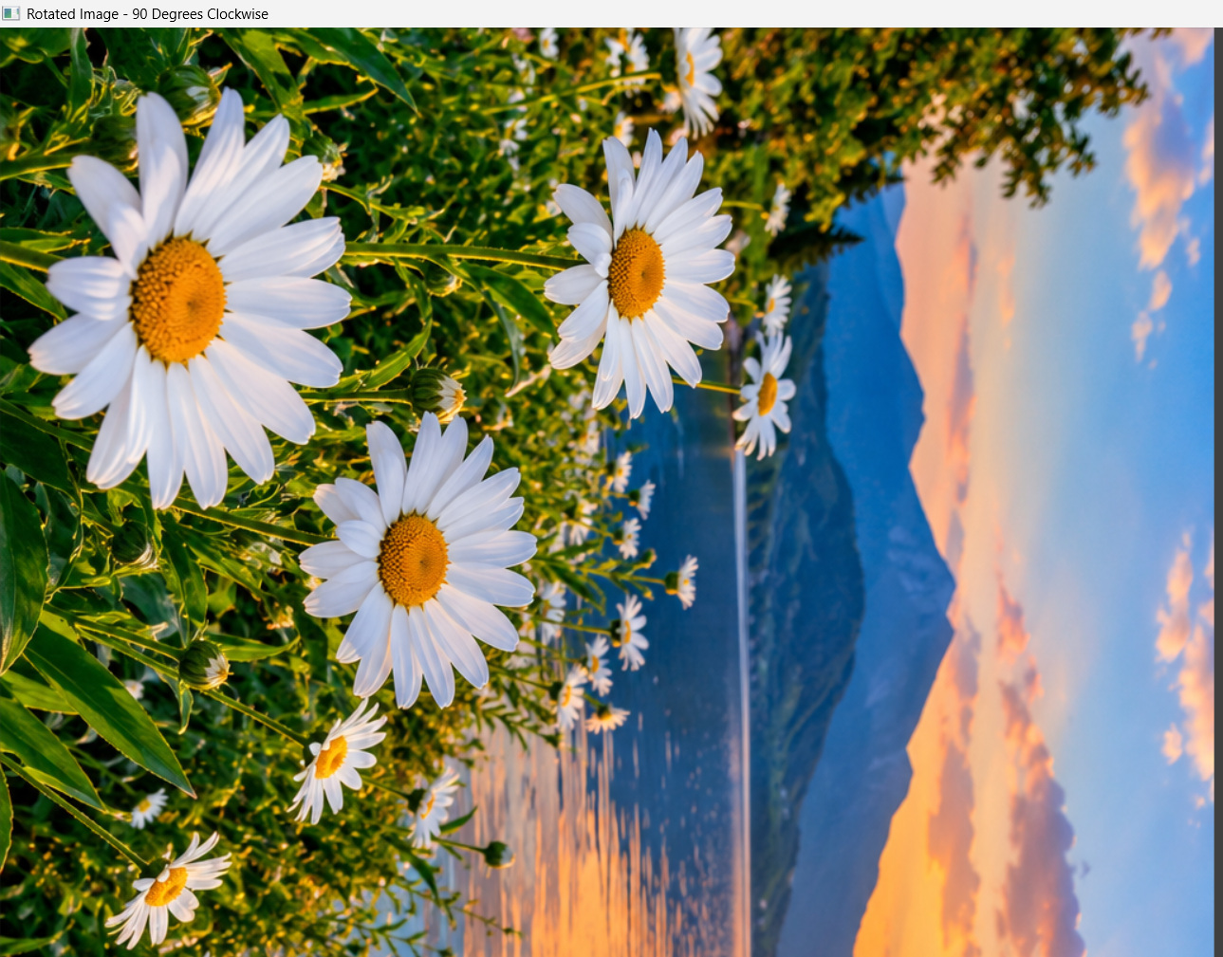
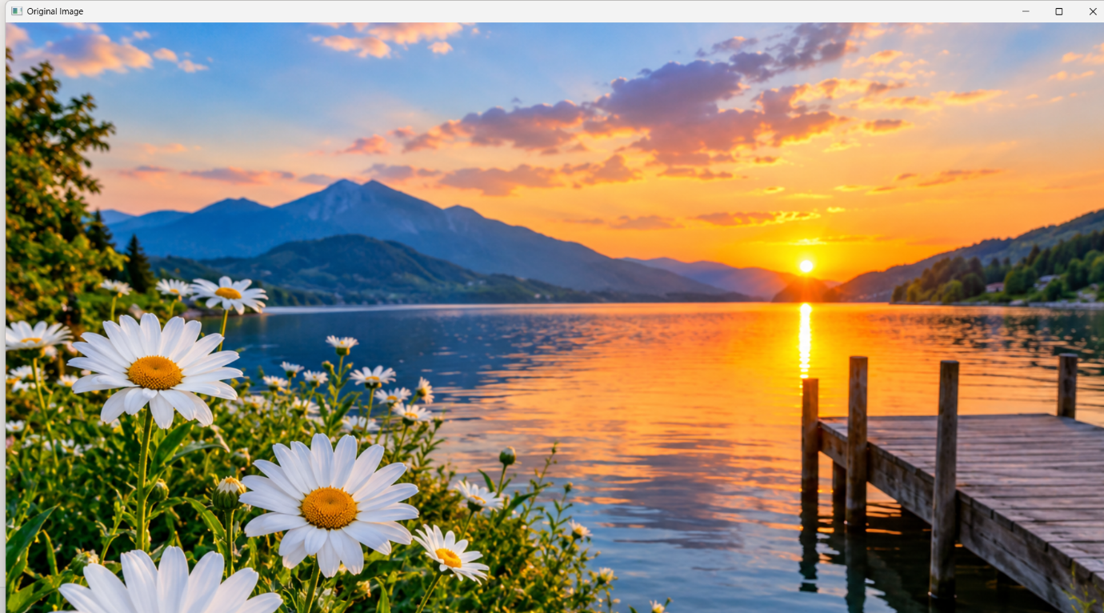

RESULT
Thus, the image was successfully rotated by 90 degrees clockwise using Python and OpenCV.

